

October 14, 2013

Dear Aqua Vista Resident,

Aqua Vista management has recently received multiple reports of bed bugs across the property. Bed bugs do not discriminate when it comes to making homes. They can infest even the cleanest homes or apartments. They are one of the hardest pests to eradicate and it takes diligent cooperation from tenants and property managers. Some complexes have even closed or sold because they could no longer afford to treat their community that were 50-90% infested. Aqua Vista is being proactive and addressing this problem “head-on”. In order to successfully combat this issue, management is asking for your help.

It is **extremely important** that you report any bed bugs in your apartment so we can schedule a treatment as soon as possible. Aqua Vista pays for any bed bug treatments as long as you, the resident, cooperates and prepares for treatment. You will only be charged if you are unprepared for a treatment. Although it is not the only way to get bed bugs, it is generally advised that you do not buy used furniture. If you buy used clothing, immediately wash it in hot water and dry in a hot dryer.

Below is a table with pictures to help you identify a bed bug. If you are experiencing “bites” at night, please personally inspect your bedding and surrounding items. If you think you may have any bed bugs in your apartment, please contact the rental office for further assistance. Please then keep your guests and/or visitors to a minimum, and do not visit other apartments. The most commonly affected areas are arms, shoulders, and legs, since they are generally uncovered during a person’s sleep. General symptoms of bed bug bites are an itchy, red spot on the bitten area. If it is found you have bed bugs, do not be alarmed. No official report has yet demonstrated that they are carries of infectious disease.

Additional information is available in the rental office if you would like further information.

Aqua Vista Apartments needs and greatly appreciates your cooperation in addressing this critical matter.

Sincerely,

Jim West

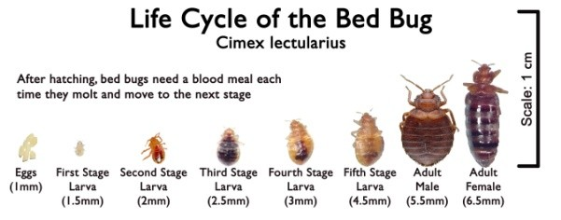

Aqua Vista Housing Manager